Scroll down for Photographic Evidence -

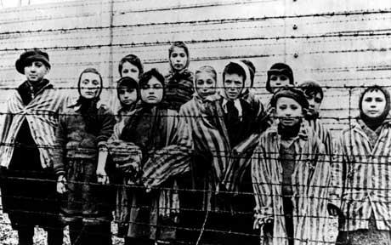
Image #1 – Jewish Children who are imprisoned in a concentration camp

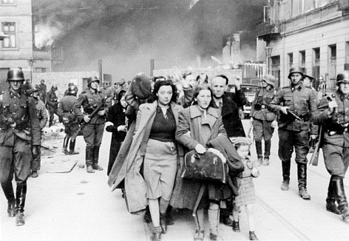
Image #2 – Jewish people being led away to the train station

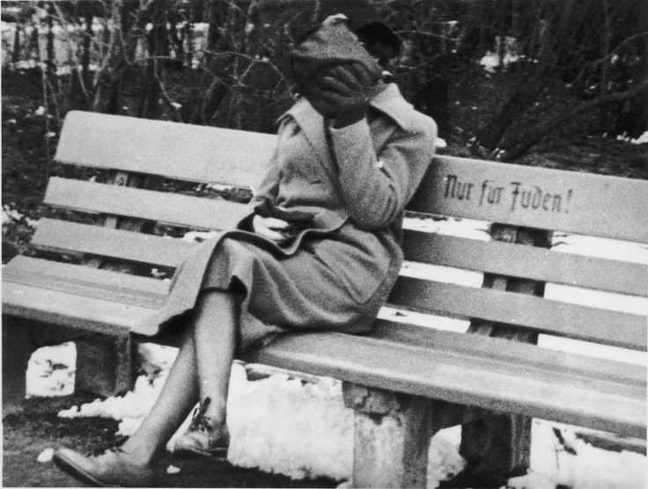
Image #3 – A Jewish woman hides her shame. She sits on a bench that says “Jews Only”.
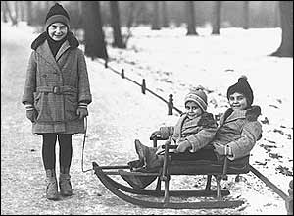
Image #4 – Jewish Children playing in the snow before WWII

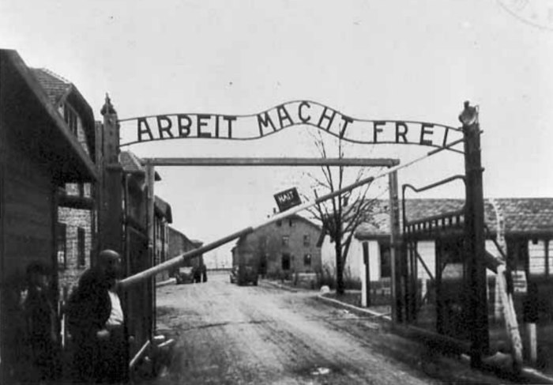
Image #5 – the entrance of Aushwitz Concentration Camp, the sign says “Work makes you free”

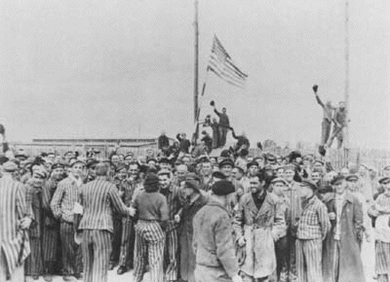
Image #6 – Liberation of a Concentration Camp by the United States Army
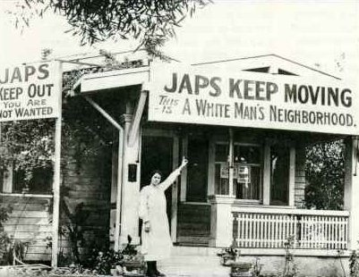
Image #7 – House in California after Pearl Harbor was attacked
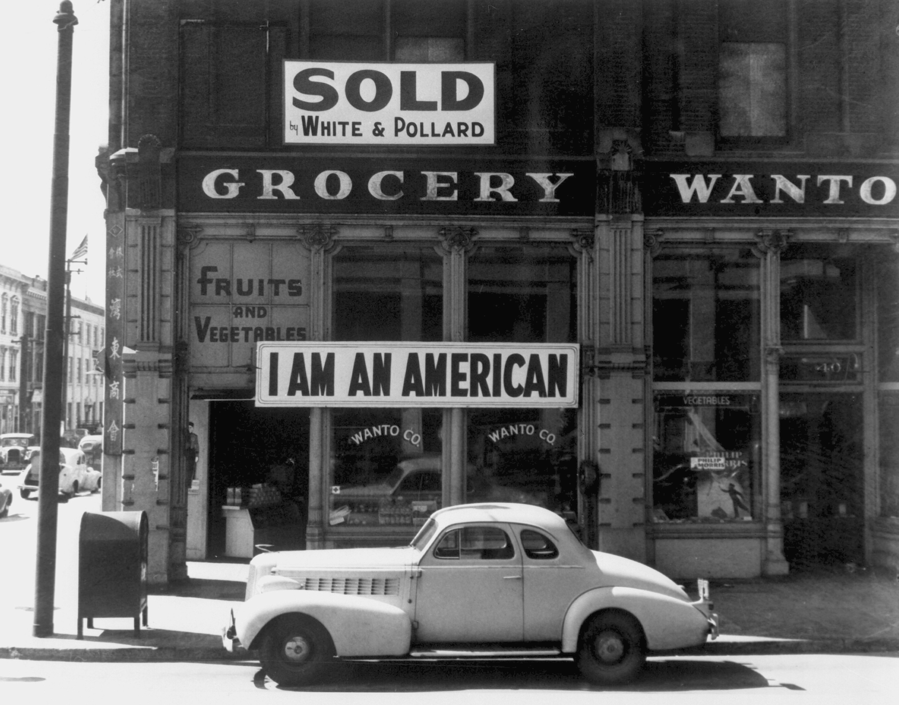
Image #10 A Japanese store owner reminding others that he is American too.
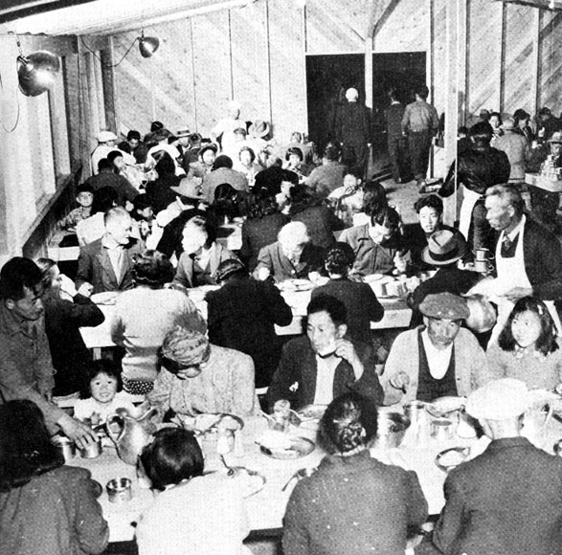 Image #8 Japanese Americans eating in an Internment Camp

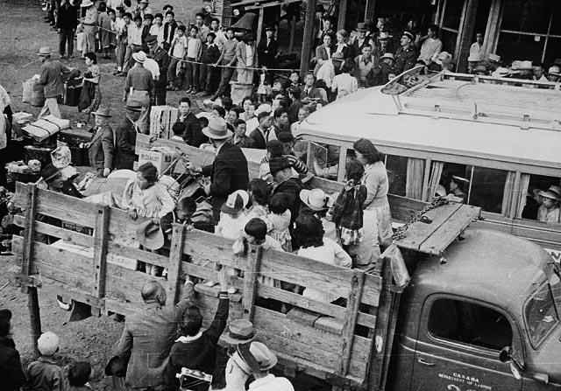
Image #9 – Japanese Americans loading into a truck to head to Internment Camps. Stated a colonel in the Western Command, "I am determined that if they have one drop of Japanese blood in them, they must go to camp."
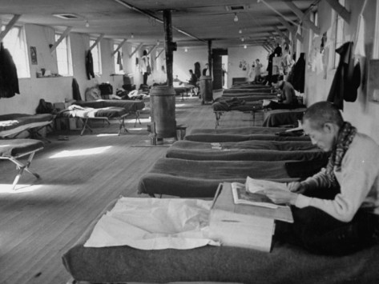
Image #10 – A Japanese American man reads in his bunk.

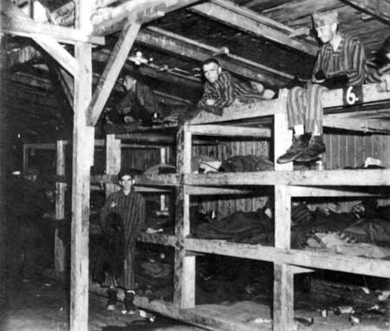
Image #12 – Jewish inmates in the bunkbeds at a concentration camp
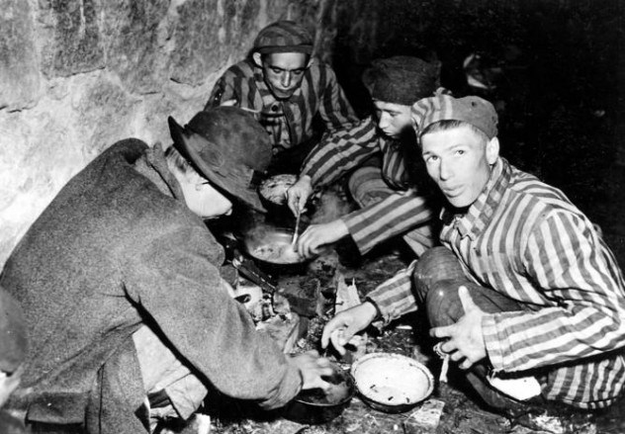
Image #13 - The daily food rations of an average prisoner were scant at best—bread made from sawdust, sausage made of mangy horses, and tea made from weeds were the norm for many prisoners. This lack of adequate nutrition led to, among other things, prisoners stealing food from the dead and—in more extreme cases of hunger—some inmates resorted to eating rotted food from the garbage, just to get some sort of nutrition.

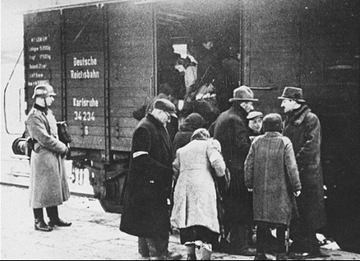
Image – 14 Jewish people were packed into box cars to travel for days without food and water to concentration camps

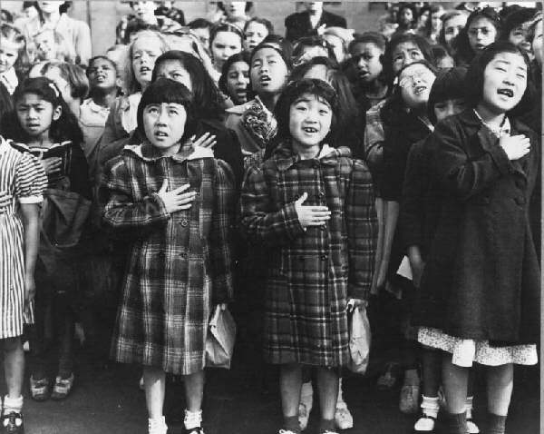
Image #15 – Japanese children singing the national anthem

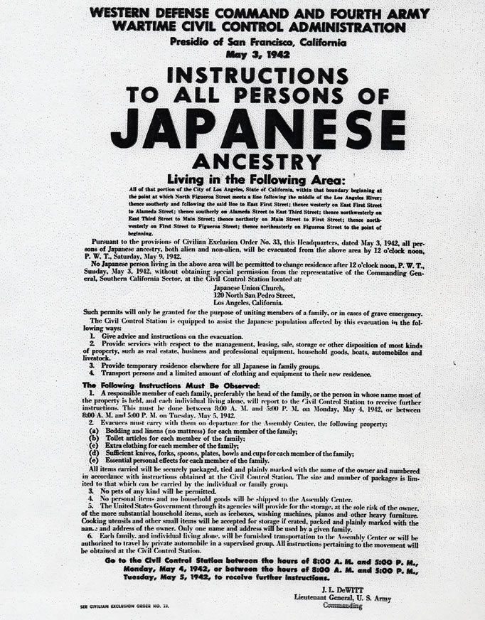
Image #16
Executive Order 9066, passed in 1942 by President Franklin Delano Roosevelt, ordered those with "Foreign Enemy Ancestry" to be sent to internment camps. Although the order did not technically name any ethnic groups, this applied to about 12,000 Japanese Americans. The U.S. Government considered these individuals to be of heightened risk to national security.
Korematsu v. United States (1944) was a significant United States Supreme Court case that ruled that the Government's use of Japanese internment camps during World War II was Constitutional. This decision, written by Justice Hugo Black, was very controversial because it was the first time the Supreme Court ruled on racial discrimination based on the strict scrutiny standard. This means that the Supreme Court applied the most stringent interpretation of the law to justify the use of Japanese internment camps as superior to individual rights. –
See more at: http://constitution.laws.com/supreme-court-decisions/korematsu-v-united-states#sthash.LcFVbzFs.dpuf
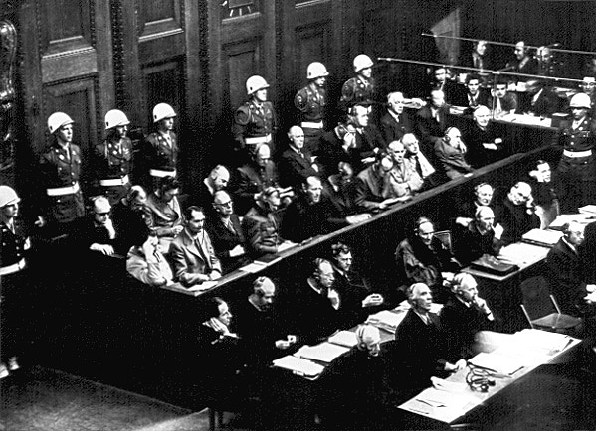
Image # 17 Nuremburg Trials - Held for the purpose of bringing Nazi war criminals to justice, the Nuremberg trials were a series of 13 trials carried out in Nuremberg, Germany, between 1945 and 1949. The defendants, who included Nazi Party officials and high-ranking military officers along with German industrialists, lawyers and doctors, were indicted on such charges as crimes against peace and crimes against humanity.

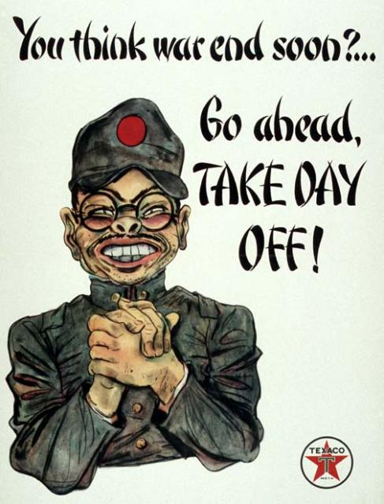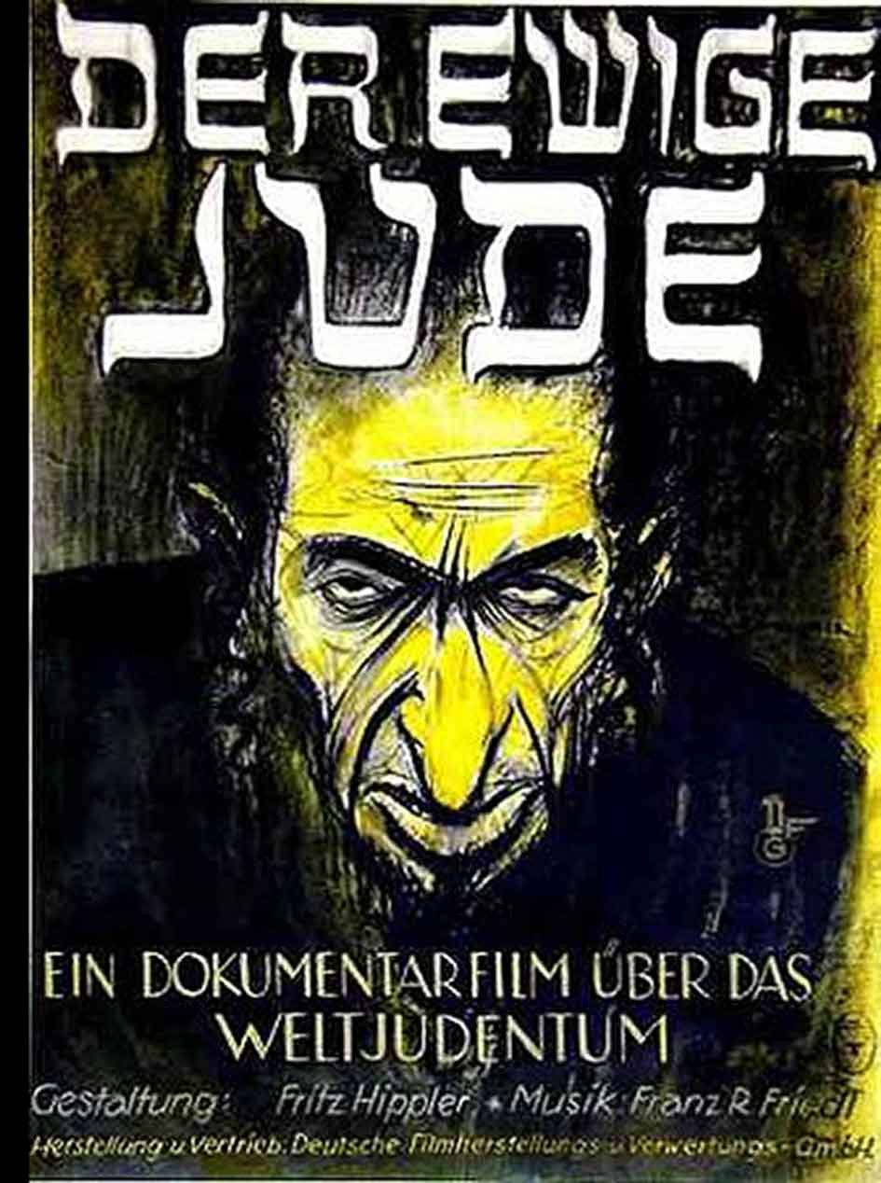
Image #18 –
American Propaganda against the Japanese versus Propaganda against the Jews

